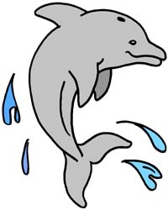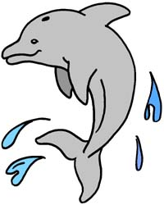

CONTACT INFORMATION

CAPTIVA COVE HOMEOWNERS ASSOCIATION
10 Lucille Street, Box 13
Fort Walton Beach, Florida 32548

Bill Taylor – President president@captivacovefl.com 850-865-1760
Brenda Bearden - Vice President vicepresident@captivacovefl.com 850-685-1692
Jean Hood - Member at Large memberatlarge@captivacovefl.com 850-217-4121
Daren Reeder – Treasurer treasurer@captivacovefl.com 850-803-5010
Kelly Taylor –Secretary secretary@captivacovefl.com 850-376-4262
General contact information for HOA Board: board@captivacovefl.com

TOWN OF CINCO BAYOU
10 Yacht Club Drive
Cinco Bayou, Florida 32548
www.cincobayou.com
850-833-3405

Jean Hood – Mayor
Keith Williams – Town Manager/Clerk
Linda Barringer – Deputy Clerk

OKALOOSA COUNTY SHERIFF’S OFFICE
50 2nd Street
Shalimar, Florida 32547
www.sheriff-okaloosa.org
Non-Emergency Number: 850-651-7400

July, 2026

