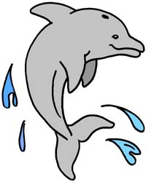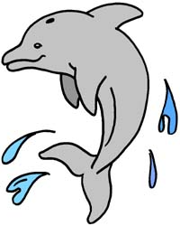
Captiva Cove
Homeowners Guidelines
Welcome to Captiva Cove Townhomes! Our mailing address is P.O. Box 4123, Fort Walton Beach, FL 32549. Although our address is Fort Walton Beach, our complex is located in the Town of Cinco Bayou. The Town Hall is located at the corner of Kidd Street and Yacht Club Drive. The Town Hall can be reserved free of charge to residents. More information may be found at www.cincobayou.com . You can contact the town staff by calling 850-833-3405.
Our complex is managed by a Homeowners Association (HOA) elected by a vote of owners at our annual meeting. Please be familiar with our agreed upon covenants and bylaws. We live in close quarters in Captiva Cove, so it is important for all residents and guests alike to respect each other's property and privacy. The following is information which we think will be helpful to you as a resident of Captiva Cove:
1. Trash pickup is on Tuesday and Friday. Only trash (household garbage in the Waste Management bin) will be picked up. Please place containers at the street on the night before scheduled pickup with the open edge facing the street. All bulk trash should be placed at the road on Thursday evening for Friday pickup. Yard waste pickup (bagged leaves, grass, shrubs and small branches four feet or less in length) will be picked up on Wednesday. Recycling pickup is on Friday, which includes newspaper, other paper, metal and aluminum cans, and plastic containers. If you have trouble with your trash pickup service, please call the Town Hall at 850-833-3405.
2. The boat dock is to be enjoyed by all residents and guests. Please pick up any trash, bait, clothes or toys before you leave the dock.
3. The parking lot is designated for two cars per unit. Please do not block the garages, sidewalks, or the paved walkway to the dock. No trailers, RV's, boats, or recreational vehicles on trailers may be parked in the parking lot for more than 15 days. Commercial autos and small trucks are allowed with limited company logos and advertisements.
4. Pets are limited to two animals per unit. All pets must be on a leash at all times when outside on the Captiva Cove property. This is required not only by our HOA guidelines but by an ordinance of the Town of Cinco Bayou. Please pick up after your pets and be respectful of other residents’ property.
5. To enhance the enjoyment of all, quiet hours have been established for all owners and their guests as well as contractors hired to do work on an owner's unit or outside the building. "Quiet hours" are as follows: After 10 pm Sunday through Thursday and after 10:30 pm on Friday and Saturday; before 8 am Monday through Friday and before 9 am on Saturday and Sunday.
6. Other than small bird feeders, please do not feed ducks or other wildlife. This is for the protection of our wildlife as well as our complex's environment.
7. Owners are responsible for maintenance of the area in front of their unit, between the garages, and the area between the garage and the house, as well as the plants around their back deck. It is asked that each owner keep their lot and deck in a neat and attractive condition.
8. To avoid damage to the seawall, the Association requests that no items be attached to the seawall and no watercraft be moored to the seawall.
9. Requests to make any structural alteration, modification, renovation, or additions to a townhome must have the prior written approval of the HOA.
10. Leases or rentals of units for less than 12 months are not permitted.
December, 2025

